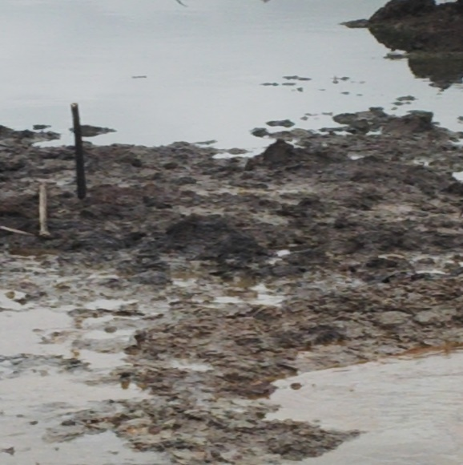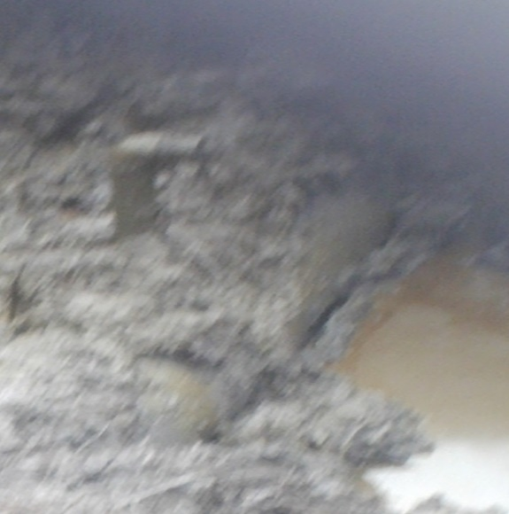
Figure 1 Overview picture of the site/spot Figure 2 The illegal valve

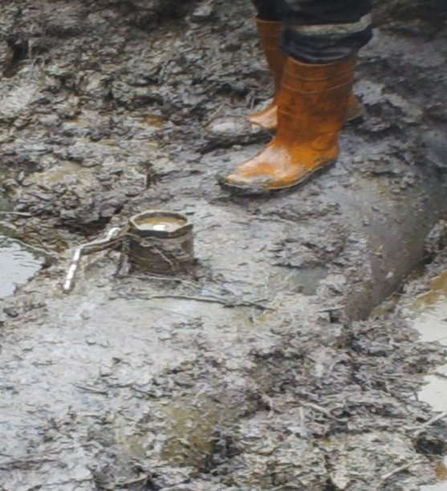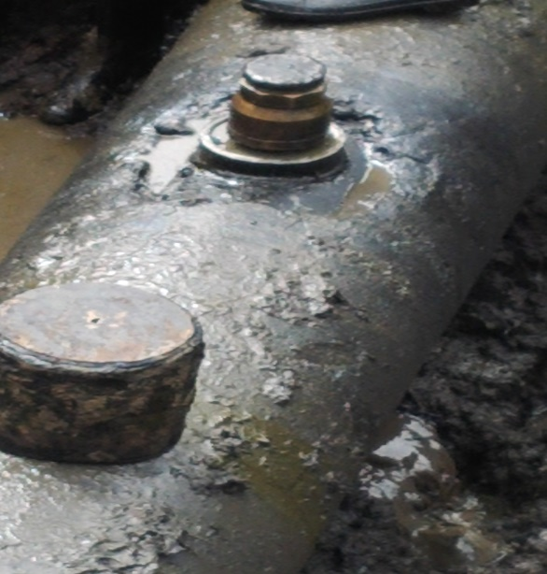
Figure 3 the illegal valve point Figure 4 the capped valve to be coned

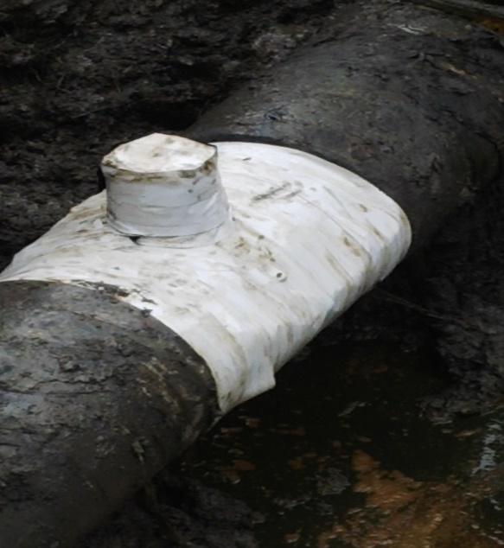
Figure 5 the wrapped stage

